**Aim:** Perform FFT and IFFT on Discrete Time Signal.

**Theory:-**

* The Fast Fourier Transform (FFT) is an algorithm used to efficiently compute the Discrete Fourier Transform (DFT) of a sequence or signal. It converts a time-domain signal into its frequency-domain representation, revealing the signal's frequency components.
* The Inverse Fast Fourier Transform (IFFT) is the reverse process of the FFT. It transforms the frequency-domain representation back into the time-domain signal.
* The FFT and IFFT are widely used in various applications, including signal processing, image processing, audio processing, and communication systems.

**Programm:-**

import matplotlib.pyplot as plt

import numpy as np

def plot_signal_and_spectrum(signal, spectrum):

# Create time axis for plotting

time_axis = np.arange(len(signal))

# Plot the original signal

plt.subplot(2, 1, 1)

plt.plot(time_axis, signal)

plt.title('Original Signal')

plt.xlabel('Time')

plt.ylabel('Amplitude')

# Plot the magnitude spectrum

plt.subplot(2, 1, 2)

plt.plot(time_axis, spectrum)

plt.title('Magnitude Spectrum')

plt.xlabel('Frequency')

plt.ylabel('Magnitude')

plt.tight_layout()

plt.show()

# Define the discrete-time signal

time = np.linspace(0, 1, 500)

frequency1 = 5 # Frequency of the first sinusoidal component

frequency2 = 20 # Frequency of the second sinusoidal component

amplitude1 = 1 # Amplitude of the first sinusoidal component

amplitude2 = 0.5 # Amplitude of the second sinusoidal component

signal = amplitude1 * np.sin(2 * np.pi * frequency1 * time) + \

amplitude2 * np.sin(2 * np.pi * frequency2 * time)

# Compute the FFT of the signal

fft_result = np.fft.fft(signal)

# Compute the magnitude spectrum of the FFT result

magnitude_spectrum = np.abs(fft_result)

# Compute the IFFT of the FFT result

reconstructed_signal = np.fft.ifft(fft_result)

# Display the original signal, the magnitude spectrum, and the reconstructed

# signal

plot_signal_and_spectrum(signal, magnitude_spectrum)

# Save the magnitude spectrum plot (optional)

spectrum_path = 'Magnitude Spectrum.png'

plt.plot(magnitude_spectrum)

plt.title('Magnitude Spectrum')

plt.xlabel('Frequency')

plt.ylabel('Magnitude')

plt.savefig(spectrum_path)

print(f"Magnitude spectrum plot saved at: {spectrum_path}")

plt.show()

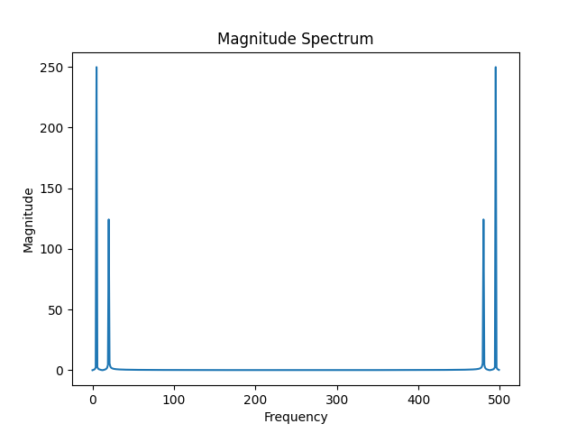**Output :-**